Category Management

Header
Module: Category Management

Overview
Purpose: Maintain transaction classifications for analysis and reporting.
Scope: View, add, edit, organise, activate, and deactivate categories.

Summary
Category Management supports viewing, adding, editing, organising, activating, and deactivating transaction categories while enforcing valid names, category nature, and parent-child hierarchy rules.

Input
- Category Name
- Nature: Need, Want, or Savings
- Optional Parent Category
- Active Status

Output
- Saved category with hierarchy and status details
- Confirmation after successful creation or update
- Validation errors for duplicate names, inactive parents, self-parenting, or circular hierarchy

Activity Diagram
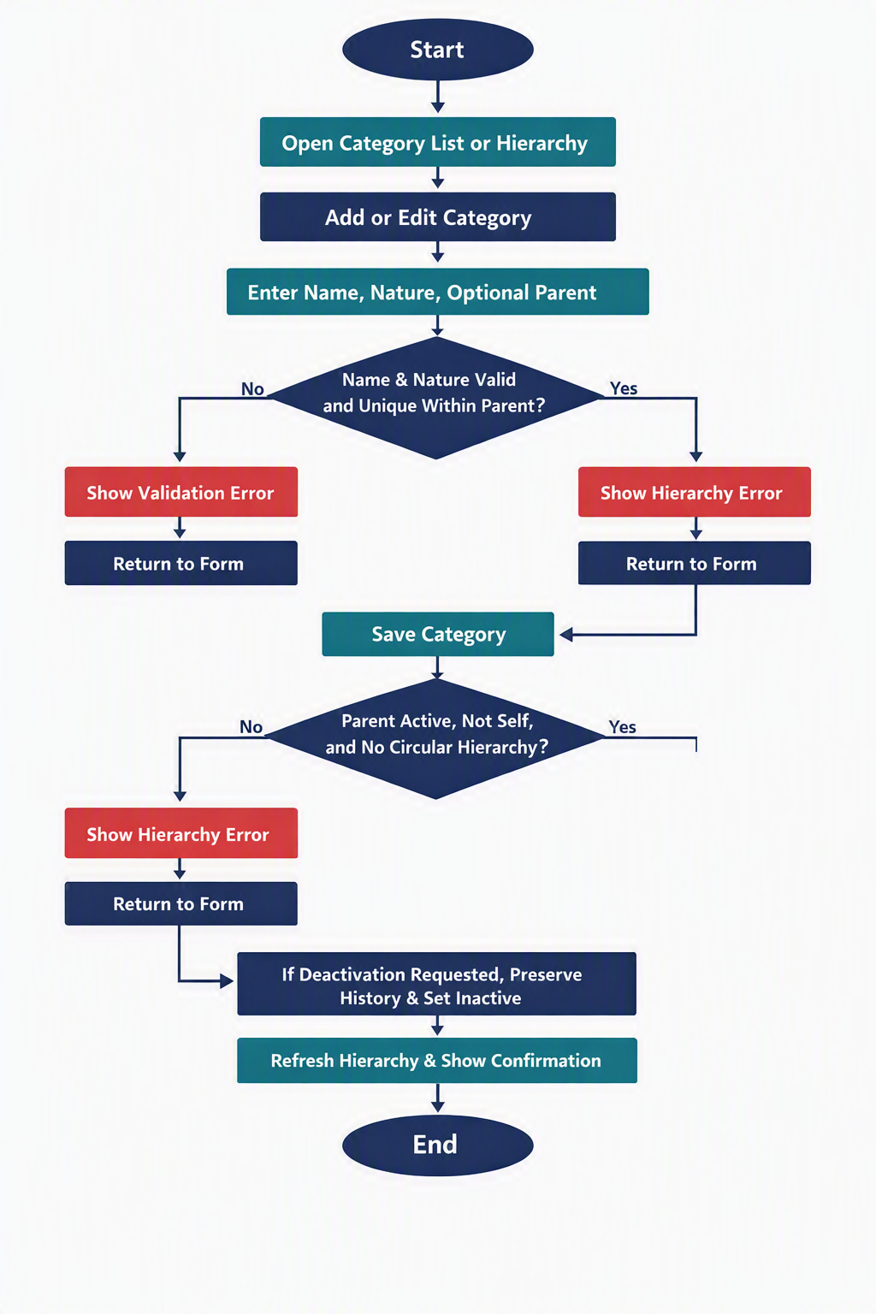
Figure 2 — Category Management activity diagram.

Screen and Process Flow
The Category List supports hierarchy and flat views. The Add/Edit Category screen contains Name, Nature, optional Parent Category, Save, and Cancel. The system validates name, nature, parent status, self-parenting, and circular hierarchy before saving.
Positive Test: Create a child category under an active parent.
Negative Test: Duplicate sibling, inactive parent, self-parenting, and circular hierarchy are rejected.

